UNITED STATES
SECURITIES AND EXCHANGE COMMISSION
WASHINGTON, D.C. 20549

FORM 8-K

CURRENT REPORT
Pursuant to Section 13 or 15(d)
of the Securities Exchange Act of 1934
Date of Report (Date of earliest event reported) August 27, 2026

TSCAN THERAPEUTICS, INC.
(Exact name of registrant as specified in its charter)

Delaware |  | 001-40603 |  | 82-5282075
(State or other jurisdiction  of incorporation) |  | (Commission  File Number) |  | (IRS Employer  Identification No.)

830 Winter Street
Waltham, Massachusetts |  | 02451
(Address of principal executive offices) |  | (Zip Code)
Registrant’s telephone number, including area code 857 399-9500
Not Applicable
(Former name or former address, if changed since last report)

Check the appropriate box below if the Form 8-K filing is intended to simultaneously satisfy the filing obligation of the registrant under any of the following provisions:

☐ | Written communications pursuant to Rule 425 under the Securities Act (17 CFR 230.425)

☐ | Soliciting material pursuant to Rule 14a-12 under the Exchange Act (17 CFR 240.14a-12)

☐ | Pre-commencement communications pursuant to Rule 14d-2(b) under the Exchange Act (17 CFR 240.14d-2(b))

☐ | Pre-commencement communications pursuant to Rule 13e-4(c) under the Exchange Act (17 CFR 240.13e-4(c))
Securities registered pursuant to Section 12(b) of the Act:

Title of each class |  | Trading  Symbol(s) |  | Name of each exchange  on which registered
Voting Common Stock, par value $0.0001 per share |  | TCRX |  | The Nasdaq Global Market, LLC
Indicate by check mark whether the registrant is an emerging growth company as defined in Rule 405 of the Securities Act of 1933 (§ 230.405 of this chapter) or Rule 12b-2 of the Securities Exchange Act of 1934 (§ 240.12b-2 of this chapter).
Emerging growth company ☒
If an emerging growth company, indicate by check mark if the registrant has elected not to use the extended transition period for complying with any new or revised financial accounting standards provided pursuant to Section 13(a) of the Exchange Act. ☐

Item 2.05. | Costs Associated with Exit or Disposal Activities.
On September 2, 2026, TScan Therapeutics, Inc. (the “Company”) initiated a prioritization strategy by which the Company will prioritize the preclinical development of its in vivo solid tumor program and pause further enrollment in its Phase 3 ALLOHA-2TM study of TSC-101. Pursuant to such strategy, the Company also implemented a workforce reduction of approximately 75% of the Company’s workforce (the “Strategic Reorganization”). The Company expects to substantially complete the Strategic Reorganization by the end of the fourth quarter of 2026. In connection with the Strategic Reorganization, the Company expects to incur approximately $4.1 million in employee-related costs, consisting primarily of pay continuation and related benefits. The Company expects that substantially all of these charges will result in future cash expenditures.
The charges the Company expects to incur in connection with the prioritization strategy are subject to a number of assumptions, risks and uncertainties, and actual results may materially differ. The Company may also incur other material charges not currently contemplated due to events that may occur as a result of, or associated with, these actions.

Item 3.01 | Notice of Delisting or Failure to Satisfy a Continued Listing Rule or Standard; Transfer of Listing.
On August 27, 2026, the Company received written notice (the “Notice”) from the Listing Qualifications Department of The Nasdaq Stock Market LLC (“Nasdaq”) stating that the Company’s voting common stock, par value $0.0001 per share (the “Common Stock”) failed to comply with the $1.00 minimum bid price required for continued listing on The Nasdaq Global Market under Nasdaq Listing Rule 5450(a)(1) (the “Minimum Bid Price Rule”) based upon the closing bid price of the Common Stock for the 30 consecutive trading days prior to the date of the Notice from Nasdaq. The Notice has no effect on the listing of the Company’s Common Stock at this time, and the Company’s Common Stock will continue to trade on the Nasdaq Global Market under the symbol “TCRX.”
The Company has been provided an initial compliance period of 180 calendar days, or until February 23, 2027, to regain compliance with the Minimum Bid Price Rule which requires that the closing bid price of the Common Stock meet or exceed $1.00 per share for a minimum of ten consecutive trading days.
If the Company does not regain compliance with Rule 5450(a)(1) by February 23, 2027, the Company may be afforded a second 180 calendar day period to regain compliance. To qualify, the Company would be required to transfer to The Nasdaq Capital Market and meet the continued listing requirement for market value of publicly held shares and all other initial listing standards for The Nasdaq Capital Market, except for the minimum bid price requirement. In addition, the Company would be required to notify Nasdaq of its intent to cure the deficiency during the second compliance period. If the Staff concludes that the Company will not be able to cure the deficiency, or if the Company does not regain compliance with the minimum bid price requirement within such additional 180 calendar day compliance period, the Staff will provide written notification to the Company that the Company’s common stock will be subject to delisting. At that time, the Company may appeal the Staff’s delisting determination to a Nasdaq Hearings Panel (“Panel”). However, there can be no assurance that, if the Company receives a delisting notice and appeals the delisting determination by the Staff to Panel, such appeal would be successful.
The Company will continue to monitor the bid price of the Common Stock and consider its available options to regain compliance with the Minimum Bid Price Rule. However, there can be no assurance that the Company will be able to regain compliance with the Minimum Bid Price Rule.

Item 5.02 | Departure of Directors or Certain Officers; Election of Directors; Appointment of Certain Officers; Compensatory Arrangements of Certain Officers.
Departure of Certain Officers
In connection with the Strategic Reorganization, effective as of September 2, 2026 (the “Effective Date”), the employment of Jason A. Amello, the Company’s Chief Financial Officer, and Chrystal Louis, M.D., MPH, the Company’s Chief Medical Officer, was terminated.
Pursuant to that certain Employment Agreement, dated as of January 29, 2024, between the Company and Mr. Amello (the “Amello Employment Agreement”), Mr. Amello’s departure from the Company will constitute a Termination without Cause (as defined in the Amello Employment Agreement), and, in accordance therewith, subject to Mr. Amello executing a release in favor of the Company, Mr. Amello is contractually entitled to receive an amount equal to 12 months of his base salary and the Company shall pay COBRA premiums for Mr. Amello and his covered dependents for a period of up to 12 months.
Pursuant to that certain Employment Agreement, dated as of April 4, 2024, between the Company and Dr. Louis (the “Louis Employment Agreement”), Dr. Louis’s departure from the Company will constitute a Termination without Cause (as defined in the Louis Employment Agreement), and, in accordance therewith, subject to Dr. Louis executing a release in favor of the Company, Dr. Louis is contractually entitled to receive an amount equal to 12 months of her base salary and any unpaid target bonus compensation applicable to fiscal year 2025 and the Company shall pay COBRA premiums for Dr. Louis and her covered dependents for a period of up to 12 months.
The foregoing descriptions of the Amello Employment Agreement and the Louis Employment Agreement do not purport to be complete and are qualified by reference to the respective agreements, which have been filed as Exhibit 10.1 to the Company’s Quarterly Report on Form 10-Q filed with the Securities and Exchange Commission (“SEC”) on May 13, 2024 and Exhibit 10.1 to the Company’s Quarterly Report on Form 10-Q filed with the SEC on August 12, 2024, respectively.

Appointment of Principal Financial Officer and Principal Accounting Officer
As of the Effective Date, Gavin MacBeath, Ph.D., the Company’s Chief Executive Officer, assumed the duties of the principal financial officer and principal accounting officer of the Company. The information required by Items 401(b) and (e) of Regulation S-K with respect to Dr. MacBeath is included in the Company’s definitive proxy statement filed with the SEC on April 17, 2026, and is hereby incorporated by reference herein. There are no related party transactions between Dr. MacBeath, on the one hand, and the Company, on the other, reportable under Item 404(a) of Regulation S-K. In addition, there is no family relationship between any director or executive officer of the Company and Dr. MacBeath.

Item 7.01 | Regulation FD Disclosure.
On September 2, 2026, the Company issued a press release announcing that it is strategically refocusing to prioritize its in vivo solid tumor program, advancing two product candidates to IND-enabling studies, as well as the Strategic Reorganization (the “Press Release”). The Company also released an updated company presentation. Copies of the press release and the updated company presentation are attached as Exhibits 99.1 and 99.2 to this Current Report on Form 8-K. The updated company presentation will also be available in the investor relations section of the Company’s website at https://ir.tscan.com. The Company also announced that it will host a webcast on Wednesday, September 2, 2026, at 8:30 a.m. ET, to discuss these updates. The live event can be accessed by visiting https://edge.media-server.com/mmc/p/a9hiygph, or via the Events and Presentations section of TScan’s website at https://ir.tscan.com/news-events/events-and-presentations. Information contained on the Company’s website is not incorporated by reference into this Current Report on Form 8-K, and you should not consider any information on, or that can be accessed from, the Company’s website as part of this Current Report on Form 8-K.
The information under this Item 7.01, including Exhibits 99.1 and 99.2 hereto, is being furnished and shall not be deemed “filed” for purposes of Section 18 of the Securities Exchange Act of 1934, as amended (the “Exchange Act”), or otherwise subject to the liabilities of that section, nor shall it be deemed incorporated by reference in any filing under the Securities Act of 1933, as amended, or the Exchange Act, except as expressly set forth by specific reference in such a filing. The Company undertakes no obligation to update, supplement or amend the material attached hereto as Exhibits 99.1 and 99.2.

Item 8.01 | Other Events.
On September 2, 2026, the Company issued the Press Release announcing it is strategically reorganizing to prioritize its in vivo solid tumor program, advancing two product candidates to IND-enabling studies, as well as the Strategic Reorganization. Key highlights are set forth below.
Solid Tumors
The Company is advancing a strategy to treat patients with in vivo-engineered TCR-T therapy candidates, initially as singleplexed therapy and ultimately as multiplexed therapy. The Company has now advanced its first two therapeutic candidates, one targeting PRAME and the other targeting MAGE-A4, into IND-enabling studies. The Company believes its in vivo engineering approach will overcome the key limitations of ex vivo-engineered autologous TCR-T, including the cost and difficulty of patient-specific manufacturing, the delay in getting product to patients, and the need for lymphodepletion. The Company expects to share preclinical data in Q1 2027 and file its first IND in Q3 2027, with plans to initiate Phase 1 development in Q4 2027.
Heme Malignancies
Data from the Phase 1 ALLOHA™ study of TSC-101 in patients with heme malignancies undergoing allogeneic hematopoietic cell transplantation (HCT) demonstrate an encouraging safety and clinical efficacy profile. Cohort A of the study demonstrated that patients treated with TSC-101 have more durable remissions and decreased relapse rates compared to control-arm patients. Additionally, early data from Cohort C, in which patients were treated with the commercial-ready manufacturing process, continue to validate the program. Despite being a cohort of patients at very high risk of relapse, all 13 of the patients currently being tracked show complete donor chimerism, including two patients who relapsed and then converted to complete donor chimerism after receiving either a third infusion of TSC-101 and/or additional targeted agents. One patient was previously disclosed to have a non-relapse mortality, unrelated to TSC-101. TSC-101 infusions continue to be generally well-tolerated and observed adverse events are consistent with post-HCT adverse events. These data provide encouraging proof-of-concept for TSC-101 in the post-transplant setting and support the potential of this therapeutic candidate.
Although these data support further development, the Company is pausing the heme malignancies program due to capital constraints. Before this pause, the trial had enrolled 7 patients on the treatment arm. The Company will continue to treat and follow these patients and conduct other study-related activities at significantly reduced ongoing costs. The Company remains committed to the care of patients and intends to continue collecting safety and efficacy data while exploring strategic partnerships that could continue to move the program forward.
Autoimmunity
The Company has identified the targets of pathogenic T-cells in HLA-B*27-associated autoimmune disorders, including ankylosing spondylitis, and is evaluating strategic partnerships for this program.
Organizational Changes
The restructuring is a result of a strategic decision to shift focus and dedicate resources to the Company’s solid tumor program. In association with pausing further development of the heme malignancies program, the Company is streamlining its operating plan and organizational structure, is eliminating its internal manufacturing organization, and is significantly reducing its research footprint. The strategic reorganization is expected to produce cumulative cost savings of $55.0 million through the end of 2027 and includes a workforce reduction of approximately 75%. The Company believes its available cash, cash equivalents and marketable securities as of June 30, 2026, will be sufficient to fund its planned operations into the fourth quarter of 2027.

Forward-Looking Statements
This Current Report on Form 8-K contains forward-looking statements that are based on the Company’s beliefs and assumptions and on information currently available to the Company on the date of this Current Report. These forward-looking statements involve substantial risks and uncertainties. Any statements in this Current Report on Form 8-K other than statements of historical fact, including statements about the Company’s future expectations, plans and prospects, constitute forward-looking statements for purposes of the safe harbor provisions under the Private Securities Litigation Reform Act of 1995. Forward-looking statements include any statements about the Company’s strategy, operations and future expectations and plans and prospects for the Company, including the Company’s ability to regain compliance with the Minimum Bid Price Rule, the Company’s intentions to actively monitor the closing bid price of the Common Stock, anticipated actions to be taken by Nasdaq, and the Company’s plans to consider implementing available options to resolve the deficiency and regain compliance with the Minimum Bid Price Rule, statements related to reorganization, including costs and charges associated with the Company’s reorganizing efforts, statements regarding the cash runway and expectations around its extension, statements relating to the Company’s decision to strategically refocus to prioritize its in vivo solid tumor program, advancing two product candidates to IND-enabling studies, the timing related thereto and the expectations related thereto, partnership prospects for its heme malignancy and autoimmune programs, as well as any other statements containing the words “anticipate,” “believe,” “estimate,” “expect,” “intend”, “goal,” “may”, “might,” “plan,” “predict,” “project,” “seek,” “target,” “potential,” “will,” “would,” “could,” “should,” “continue,” and similar expressions. Such forward-looking statements involve substantial risks and uncertainties that could cause the Company’s financial and operating results, performance or achievements to differ significantly from those expressed or implied by the forward-looking statements, including the risk that the Company cannot regain compliance to maintain its listing on Nasdaq, the risk that the reorganizing costs and charges associated with the Company’s reorganizing efforts may be greater than anticipated or incurred in different periods than anticipated; the risk that the Company’s reorganizing efforts may adversely affect the Company’s internal programs and the Company’s ability to recruit and retain skilled and motivated personnel, and may be distracting to employees and management; the risk that the Company’s reorganizing efforts may negatively impact the Company’s business operations and reputation; the risk that the Company’s reorganizing efforts may not generate their intended benefits to the extent or as quickly as anticipated, including with respect to the cash runway, as well as the factors discussed in the “Risk Factors” section contained in the quarterly and annual reports that the Company files with the Securities and Exchange Commission. Any forward-looking statements represent the Company’s views only as of the date of this Current Report on Form 8-K. The Company anticipates that subsequent events and developments may cause its views to change. While the Company may elect to update these forward-looking statements at some point in the future, the Company specifically disclaims any obligation to do so except as required by law even if new information becomes available in the future.

Item 9.01 | Financial Statements and Exhibits.
(d) Exhibits:

Exhibit  No. |  | Description
99.1 |  | Press release, dated September 2, 2026
99.2 |  | Company Presentation, dated September 2, 2026
104 |  | Cover Page Interactive Data File (embedded within the Inline XBRL document)

SIGNATURES
Pursuant to the requirements of the Securities Exchange Act of 1934, the registrant has duly caused this report to be signed on its behalf by the undersigned hereunto duly authorized.

 |  |  |  |  |  | TScan Therapeutics, Inc.
Date: September 2, 2026 |  |  |  | By: |  | /s/ Gavin MacBeath, Ph.D.
Gavin MacBeath, Ph.D.
Chief Executive Officer
(Principal Executive Officer)
Exhibit 99.1


TScan Therapeutics Announces Strategic Reorganization to Focus on in vivo Cell Therapy for Solid Tumors
Advances two in vivo-engineered TCR-T candidates for solid tumors to IND-enabling studies with plans to initiate Phase 1 development in Q4 2027
Reports updated data from Cohort C of the Phase 1 ALLOHA study; 100% (13/13) patients currently being tracked show complete donor chimerism
Pauses further enrollment in Phase 3 ALLOHA-2 study of TSC-101 due to insufficient capital; allowing data to mature and actively seeking collaboration partners
Workforce reduction of approximately 75% and strategic reorganization focuses resources on solid tumors and extends runway into Q4 2027
Company to host webcast today, September 2, at 8:30 a.m. ET
WALTHAM, Mass., SEPTEMBER 2, 2026 — TScan Therapeutics, Inc. (Nasdaq: TCRX), a clinical-stage biotechnology company focused on the development of T cell receptor (TCR)-engineered T cell (TCR-T) therapies for the treatment of patients with cancer, today announced it is strategically reorganizing to prioritize its in vivo solid tumor program, advancing two product candidates to IND-enabling studies.
The Company also announced updated data from Cohort C of its Phase 1 ALLOHA study of TSC-101 in heme malignancies. All patients (13/13) currently being tracked show complete donor chimerism, including two patients who had previously relapsed. TScan has paused further enrollment in the Phase 3 ALLOHA-2 study of TSC-101 due to insufficient capital needed to complete the trial. The Company will continue to track the 7 patients already enrolled on the treatment arm of ALLOHA-2, as well as the 13 patients in Cohort C of the Phase 1 ALLOHA study. The Company remains committed to reporting updated data on Cohort C patients in Q4 2026 and on all patients treated with the commercial-ready manufacturing process in Q2 2027 and intends to pursue strategic partnerships for its heme and autoimmune programs.
As part of the strategy to prioritize the solid tumor program, the Company will undergo a workforce reduction of approximately 75%. TScan believes that concentrating its capital resources on developing the in vivo-engineered TCR-T product candidates for solid tumor indications, while preserving the potential value of its other programs through strategic partnerships, provides the strongest path forward to creating long-term value for patients and shareholders.
“Last year TScan took a first step towards streamlining the company, enabling us to advance our most promising science,” said Gavin MacBeath, Ph.D., Chief Executive Officer. “We have now seen very encouraging data on patients treated with our commercial-ready manufacturing process for TSC-101, and we firmly believe this is an important product candidate that has the potential to solve a major unmet medical need in heme malignancies. Because we are limited by our ability to access the substantial capital resources needed to complete the Phase 3 trial, we have made the difficult decision to allocate our resources to programs we believe better allow us to create value for all stakeholders, including patients. We have achieved significant clinical, manufacturing, and regulatory success with our heme program, and I am optimistic that it will proceed forward once the data mature and a strategic partner is engaged. I am extremely proud of the team for all they have achieved with this program and am particularly grateful to those employees who are leaving TScan for all they have done to advance our mission.”

Dr. MacBeath continued, “We have made the strategic decision to focus on our in vivo-engineered TCR-T program for solid tumor indications. Our goal is to build on the promise of our prior work, using our two most active TCRs from our ex vivo-manufactured TCR-T program (the Phase 1 PLEXI-T study). We believe that the in vivo engineering approach solves the key challenges of traditional autologous cell therapy and that we can build on the remarkable successes we have seen in this field to advance in vivo TCR-T therapy for patients with solid tumors. Our team has made tremendous progress over the past year, and we are now on a path to initiating Phase 1 development by the end of next year.”
Solid Tumors
TScan is advancing a strategy to treat patients with in vivo-engineered TCR-T therapy candidates, initially as singleplexed therapy and ultimately as multiplexed therapy. The Company has now advanced their first two therapeutic candidates, one targeting PRAME and the other targeting MAGE-A4, into IND-enabling studies. The Company believes its in vivo engineering approach will overcome the key limitations of ex vivo-engineered autologous TCR-T, including the cost and difficulty of patient-specific manufacturing, the delay in getting product to patients, and the need for lymphodepletion. The Company expects to share preclinical data in Q1 2027 and file its first IND in Q3 2027, with plans to initiate Phase 1 development in Q4 2027.
Heme Malignancies
Data from the Phase 1 ALLOHA study of TSC-101 in patients with heme malignancies undergoing allogeneic hematopoietic cell transplantation (HCT) demonstrate an encouraging safety and clinical efficacy profile. Cohort A of the study demonstrated that patients treated with TSC-101 have more durable remissions and decreased relapse rates compared to control-arm patients. Additionally, early data from Cohort C, in which patients were treated with the commercial-ready manufacturing process, continue to validate the program. Despite being a cohort of patients at very high risk of relapse, all 13 of the patients currently being tracked show complete donor chimerism, including two patients who relapsed and then converted to complete donor chimerism after receiving either a third infusion of TSC-101 and/or additional targeted agents. One patient was previously disclosed to have a non-relapse mortality, unrelated to TSC-101. TSC-101 infusions continue to be generally well-tolerated and observed adverse events are consistent with post-HCT adverse events. These data provide encouraging proof-of-concept for TSC-101 in the post-transplant setting and support the potential of this therapeutic candidate.
Although these data support further development, the Company is pausing the heme malignancies program due to capital constraints. Before this pause, the trial had enrolled 7 patients on the treatment arm. TScan will continue to treat and follow these patients and conduct other study-related activities at significantly reduced ongoing costs. TScan remains committed to the care of patients and intends to continue collecting safety and efficacy data while exploring strategic partnerships that could continue to move the program forward.
Autoimmunity
The Company has identified the targets of pathogenic T-cells in HLA-B*27-associated autoimmune disorders, including ankylosing spondylitis, and is evaluating strategic partnerships for this program.

Organizational Changes
The restructuring announced today is a result of a strategic decision to shift focus and dedicate resources to our solid tumor program. In association with pausing further development of the heme malignancies program, TScan is streamlining its operating plan and organizational structure, is eliminating its internal manufacturing organization, and is significantly reducing its research footprint. This strategic reorganization is expected to produce cumulative cost savings of $55.0 million through the end of 2027 and includes a workforce reduction of approximately 75%. TScan believes its available cash, cash equivalents and marketable securities as of June 30, 2026, will be sufficient to fund its planned operations into Q4 2027.
Webcast to discuss business updates
The Company will host a webcast today to discuss the strategic reorganization to focus on in vivo cell therapy for solid tumors today, Wednesday, September 2, 2026, at 8:30 a.m. ET. Participants can register and access the webcast using this link. A replay will be available following the webcast, accessible at the same link.
About TScan Therapeutics, Inc.
TScan is a clinical-stage biotechnology company focused on the development of T cell receptor (TCR)-engineered T cell (TCR-T) therapies for the treatment of patients with cancer. The Company is advancing two therapeutics candidates through IND-enabling studies to treat solid tumors using in vivo-engineered TCR-T cells. In addition, the Company is seeking partnerships for its heme and autoimmune programs. To learn more, visit www.tscan.com and connect with us on LinkedIn and X.
Forward-Looking Statements
This release contains forward-looking statements within the meaning of the Private Securities Litigation Reform Act of 1995, including, but not limited to, express or implied statements regarding TScan’s plans, progress, and timing relating to TScan’s solid tumor program, including preclinical and clinical development, strategy regarding singleplexing and multiplexing, presentation of data, and submission of an IND application; TScan’s plans, progress, expectations, and timing relating to TScan’s hematologic malignancies program, including presentation of data from the ALLOHA and ALLOHA-2 clinical trials and the implications of such results, dosing of patients, and strategic partnerships; TScan’s plans, process, expectations, and timing relating TScan’s autoimmunity program; the potential benefits of any of TScan’s proprietary platforms or current or future product candidates in treating patients; TScan’s ability to fund its operating plan into the fourth quarter of 2027 with its existing cash, cash equivalents, and marketable securities; the expected charges, cost reductions and savings, and capital preservation associated with the strategic reorganization; and TScan’s goals, strategy, and anticipated financial performance. TScan intends such forward-looking statements to be covered by the safe harbor provisions for forward-looking statements contained in Section 21E of the Securities Exchange Act of 1934 and the Private Securities Litigation Reform Act of 1995. In some cases, you can identify forward-looking statements by terms such as, but not limited to, “may,” “might,” “will,” “objective,” “intend,” “should,” “could,” “can,” “would,” “expect,” “believe,” “anticipate,” “project,” “target,” “design,” “estimate,” “predict,” “potential,” “plan,” “on track,” or similar expressions or the negative of those terms. Such forward-looking statements are based upon current expectations that involve risks, changes in circumstances, assumptions, and

uncertainties. The express or implied forward-looking statements included in this release are only predictions and are subject to a number of risks, uncertainties and assumptions, including, without limitation: the beneficial characteristics, safety, efficacy, therapeutic effects and potential advantages of TScan’s TCR-T therapy product candidates; TScan’s expectations regarding its preclinical studies or clinical trials being predictive of future clinical trial results; TScan’s cleared INDs being indicative or predictive of bringing TScan closer to its goal of providing customized TCR-T therapies to treat patients with cancer; the timing of the launch, initiation, progress, expected results and announcements of TScan’s preclinical studies, clinical trials and its research and development programs; TScan’s ability to enroll patients for its clinical trials within its expected timeline; TScan’s plans relating to developing and commercializing its TCR-T therapy product candidates, if approved, including sales strategy; estimates of the size of the addressable market for TScan’s TCR-T therapy product candidates; TScan’s manufacturing capabilities and the scalable nature of its manufacturing process; TScan’s estimates regarding expenses, future milestone payments and revenue, capital requirements and needs for additional financing; TScan’s expectations regarding competition; TScan’s anticipated growth strategies; TScan’s ability to attract or retain key personnel; TScan’s ability to establish and maintain development partnerships and collaborations; TScan’s expectations regarding federal, state and foreign regulatory requirements; TScan’s ability to obtain and maintain intellectual property protection for its proprietary platform technology and our product candidates; the sufficiency of TScan’s existing capital resources to fund its future operating expenses and capital expenditure requirements; and other factors that are described in the “Risk Factors” and “Management’s Discussion and Analysis of Financial Condition and Results of Operations” sections of TScan’s most recent Annual Report on Form 10-K and any other filings that TScan has made or may make with the SEC in the future. Any forward-looking statements contained in this release represent TScan’s views only as of the date hereof and should not be relied upon as representing its views as of any subsequent date. Except as required by law, TScan explicitly disclaims any obligation to update any forward-looking statements.
Investor and Media Contact
Caileigh Dougherty
AVP, Head of Corporate Communications & Investor Relations
857-399-9890
cdougherty@tscan.com

Corporate Presentation September 2026 Exhibit 99.2

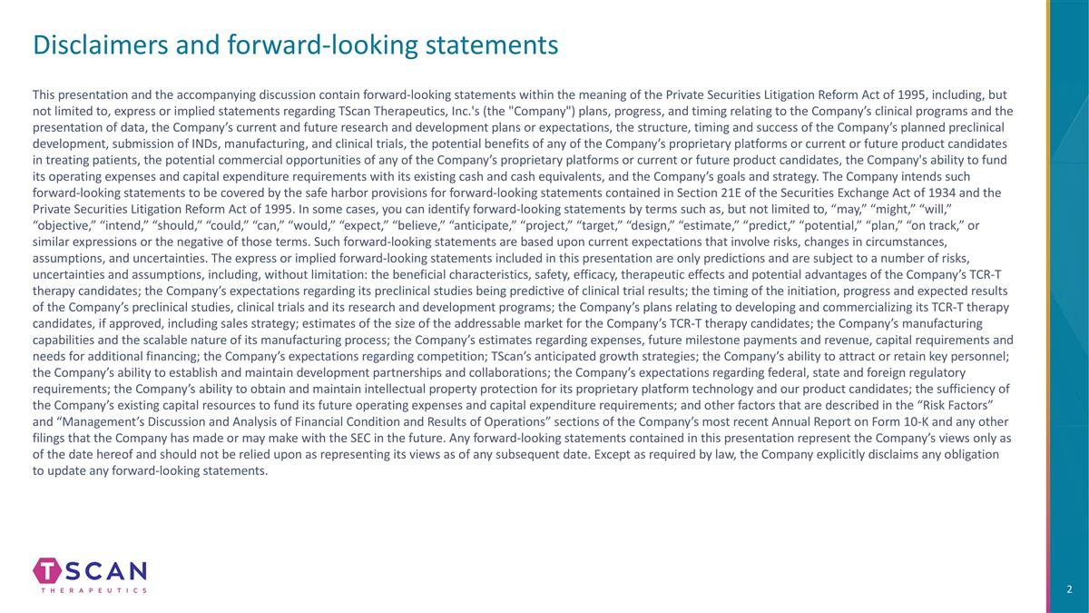
Disclaimers and forward-looking statements This presentation and the accompanying discussion contain forward-looking statements within the meaning of the Private Securities Litigation Reform Act of 1995, including, but not limited to, express or implied statements regarding TScan Therapeutics, Inc.'s (the "Company") plans, progress, and timing relating to the Company’s clinical programs and the presentation of data, the Company’s current and future research and development plans or expectations, the structure, timing and success of the Company’s planned preclinical development, submission of INDs, manufacturing, and clinical trials, the potential benefits of any of the Company’s proprietary platforms or current or future product candidates in treating patients, the potential commercial opportunities of any of the Company’s proprietary platforms or current or future product candidates, the Company's ability to fund its operating expenses and capital expenditure requirements with its existing cash and cash equivalents, and the Company’s goals and strategy. The Company intends such forward-looking statements to be covered by the safe harbor provisions for forward-looking statements contained in Section 21E of the Securities Exchange Act of 1934 and the Private Securities Litigation Reform Act of 1995. In some cases, you can identify forward-looking statements by terms such as, but not limited to, “may,” “might,” “will,” “objective,” “intend,” “should,” “could,” “can,” “would,” “expect,” “believe,” “anticipate,” “project,” “target,” “design,” “estimate,” “predict,” “potential,” “plan,” “on track,” or similar expressions or the negative of those terms. Such forward-looking statements are based upon current expectations that involve risks, changes in circumstances, assumptions, and uncertainties. The express or implied forward-looking statements included in this presentation are only predictions and are subject to a number of risks, uncertainties and assumptions, including, without limitation: the beneficial characteristics, safety, efficacy, therapeutic effects and potential advantages of the Company’s TCR-T therapy candidates; the Company’s expectations regarding its preclinical studies being predictive of clinical trial results; the timing of the initiation, progress and expected results of the Company’s preclinical studies, clinical trials and its research and development programs; the Company’s plans relating to developing and commercializing its TCR-T therapy candidates, if approved, including sales strategy; estimates of the size of the addressable market for the Company’s TCR-T therapy candidates; the Company’s manufacturing capabilities and the scalable nature of its manufacturing process; the Company’s estimates regarding expenses, future milestone payments and revenue, capital requirements and needs for additional financing; the Company’s expectations regarding competition; TScan’s anticipated growth strategies; the Company’s ability to attract or retain key personnel; the Company’s ability to establish and maintain development partnerships and collaborations; the Company’s expectations regarding federal, state and foreign regulatory requirements; the Company’s ability to obtain and maintain intellectual property protection for its proprietary platform technology and our product candidates; the sufficiency of the Company’s existing capital resources to fund its future operating expenses and capital expenditure requirements; and other factors that are described in the “Risk Factors” and “Management’s Discussion and Analysis of Financial Condition and Results of Operations” sections of the Company’s most recent Annual Report on Form 10-K and any other filings that the Company has made or may make with the SEC in the future. Any forward-looking statements contained in this presentation represent the Company’s views only as of the date hereof and should not be relied upon as representing its views as of any subsequent date. Except as required by law, the Company explicitly disclaims any obligation to update any forward-looking statements.

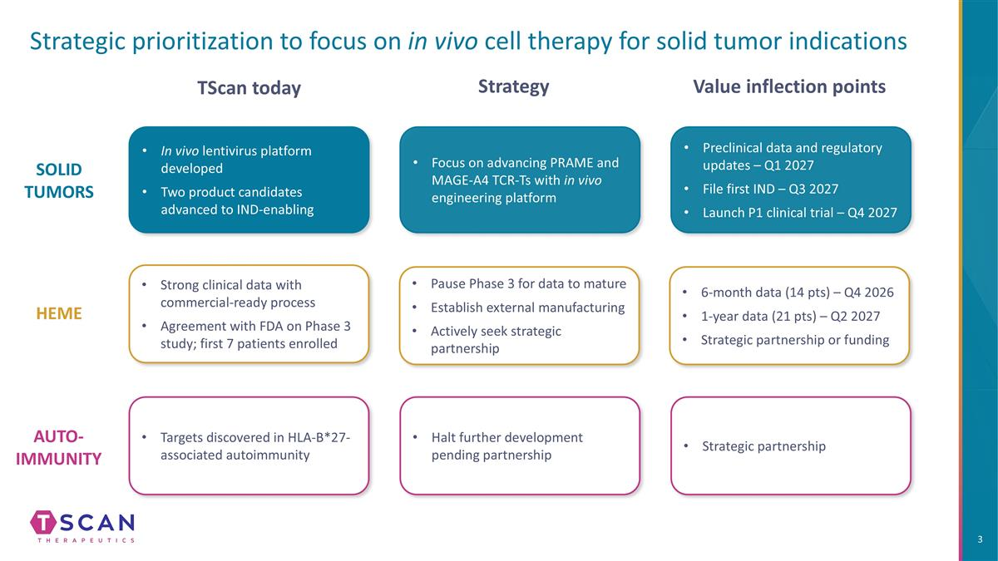
Strategic prioritization to focus on in vivo cell therapy for solid tumor indications In vivo lentivirus platform developed Two product candidates advanced to IND-enabling Preclinical data and regulatory updates – Q1 2027 File first IND – Q3 2027 Launch P1 clinical trial – Q4 2027 SOLID TUMORS HEME AUTO- IMMUNITY Focus on advancing PRAME and MAGE-A4 TCR-Ts with in vivo engineering platform Strong clinical data with commercial-ready process Agreement with FDA on Phase 3 study; first 7 patients enrolled Pause Phase 3 for data to mature Establish external manufacturing Actively seek strategic partnership 6-month data (14 pts) – Q4 2026 1-year data (21 pts) – Q2 2027 Strategic partnership or funding Targets discovered in HLA-B*27-associated autoimmunity Halt further development pending partnership TScan today Strategy Value inflection points Strategic partnership

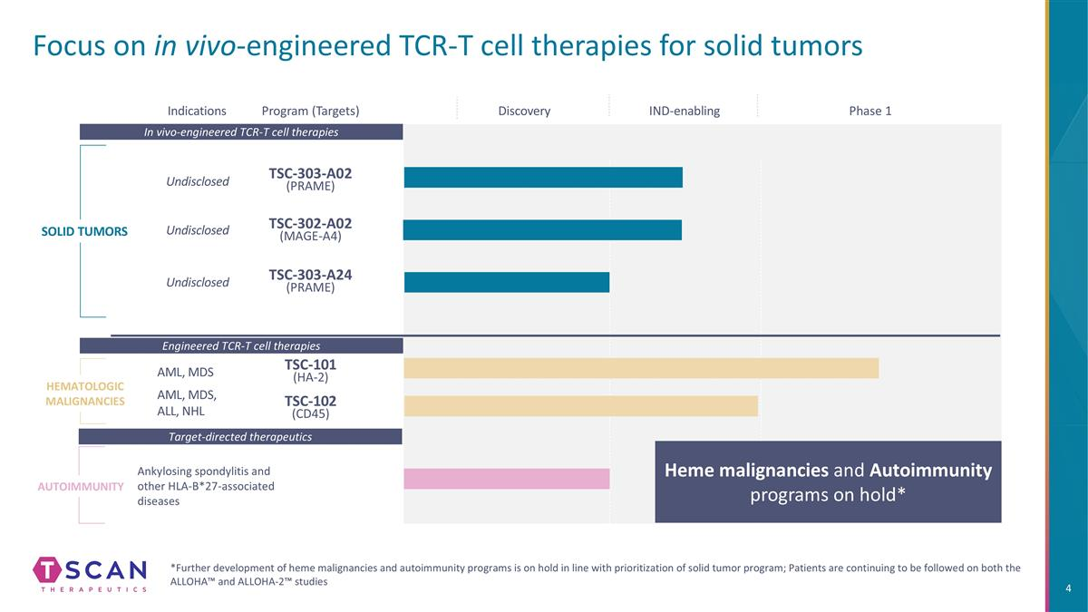
Focus on in vivo-engineered TCR-T cell therapies for solid tumors Indications Program (Targets) SOLID TUMORS Autoimmunity IND-enabling Phase 1 Target-directed therapeutics In vivo-engineered TCR-T cell therapies Ankylosing spondylitis and other HLA-B*27-associated diseases Discovery TSC-303-A02 (PRAME) TSC-101 (HA-2) HEMATOLOGIC MALIGNANCIES AML, MDS TSC-102 (CD45) Heme malignancies and Autoimmunity programs on hold* *Further development of heme malignancies and autoimmunity programs is on hold in line with prioritization of solid tumor program; Patients are continuing to be followed on both the ALLOHA™ and ALLOHA-2™ studies Engineered TCR-T cell therapies TSC-302-A02 (MAGE-A4) TSC-303-A24 (PRAME) Undisclosed Undisclosed Undisclosed AML, MDS, ALL, NHL

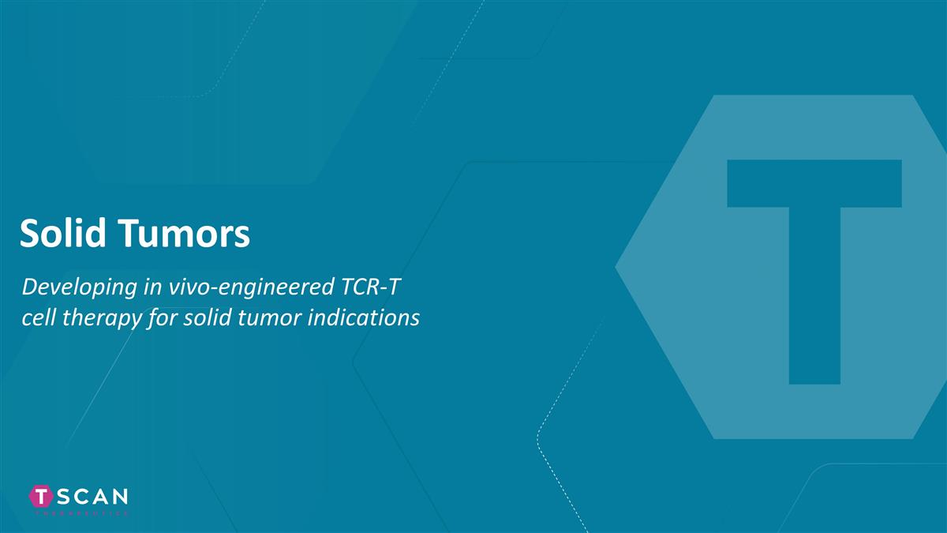
Solid Tumors Developing in vivo-engineered TCR-T cell therapy for solid tumor indications

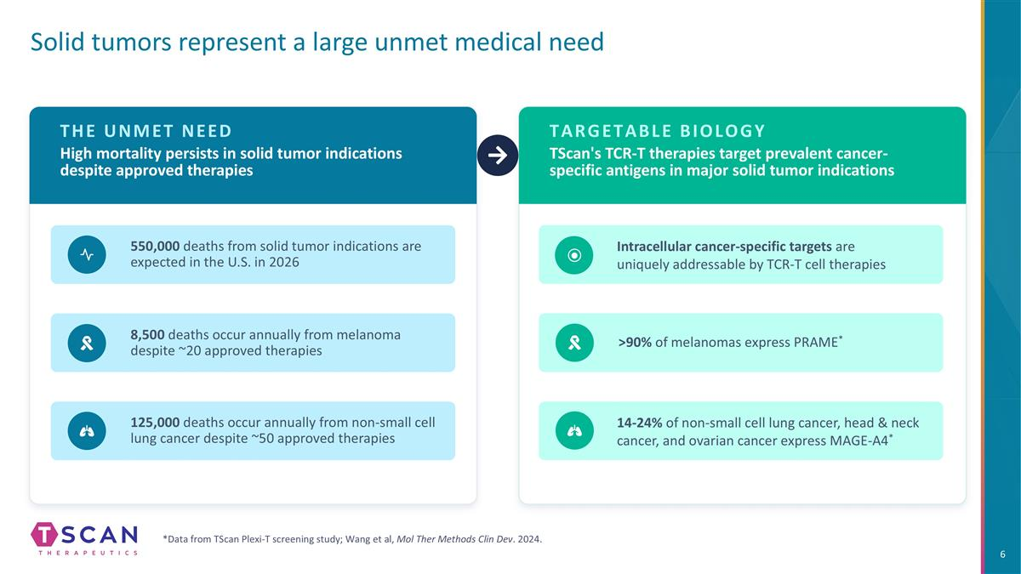
THE UNMET NEED High mortality persists in solid tumor indications despite approved therapies 550,000 deaths from solid tumor indications are expected in the U.S. in 2026 125,000 deaths occur annually from non-small cell lung cancer despite ~50 approved therapies TARGETABLE BIOLOGY TScan's TCR-T therapies target prevalent cancer-specific antigens in major solid tumor indications >90% of melanomas express PRAME* 14-24% of non-small cell lung cancer, head & neck cancer, and ovarian cancer express MAGE-A4* 8,500 deaths occur annually from melanoma despite ~20 approved therapies *Data from TScan Plexi-T screening study; Wang et al, Mol Ther Methods Clin Dev. 2024. Solid tumors represent a large unmet medical need Intracellular cancer-specific targets are uniquely addressable by TCR-T cell therapies

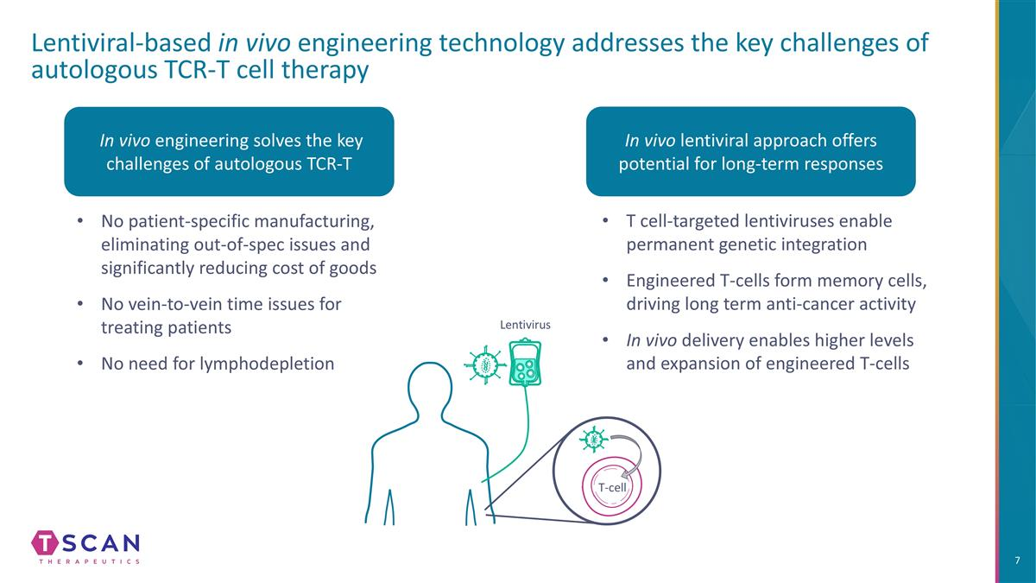
Lentivirus Lentiviral-based in vivo engineering technology addresses the key challenges of autologous TCR-T cell therapy In vivo engineering solves the key challenges of autologous TCR-T No patient-specific manufacturing, eliminating out-of-spec issues and significantly reducing cost of goods No vein-to-vein time issues for treating patients No need for lymphodepletion In vivo lentiviral approach offers potential for long-term responses T cell-targeted lentiviruses enable permanent genetic integration Engineered T-cells form memory cells, driving long term anti-cancer activity In vivo delivery enables higher levels and expansion of engineered T-cells T-cell

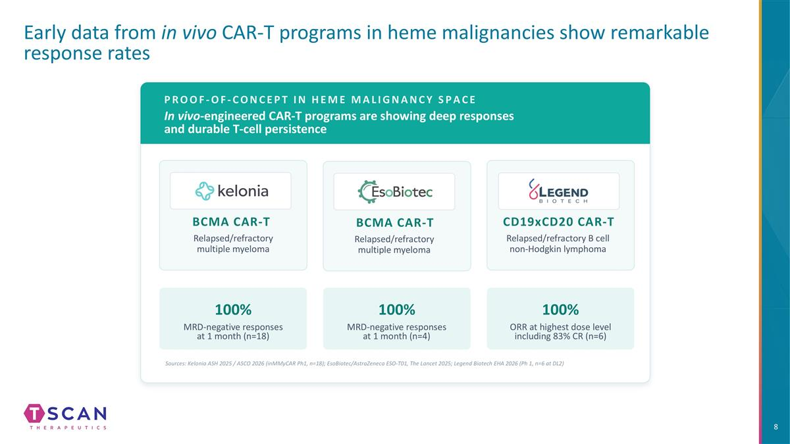
Early data from in vivo CAR-T programs in heme malignancies show remarkable response rates PROOF-OF-CONCEPT IN HEME MALIGNANCY SPACE In vivo-engineered CAR-T programs are showing deep responses and durable T-cell persistence 100% MRD-negative responses at 1 month (n=18) 100% MRD-negative responses at 1 month (n=4) 100% ORR at highest dose level including 83% CR (n=6) BCMA CAR-T Relapsed/refractory multiple myeloma BCMA CAR-T Relapsed/refractory multiple myeloma CD19xCD20 CAR-T Relapsed/refractory B cell non-Hodgkin lymphoma Sources: Kelonia ASH 2025 / ASCO 2026 (inMMyCAR Ph1, n=18); EsoBiotec/AstraZeneca ESO-T01, The Lancet 2025; Legend Biotech EHA 2026 (Ph 1, n=6 at DL2)

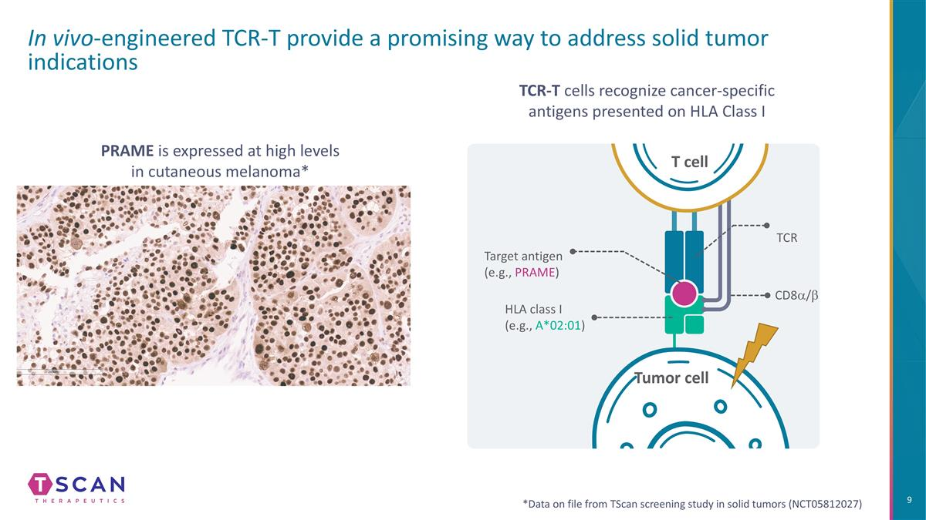
In vivo-engineered TCR-T provide a promising way to address solid tumor indications Tumor cell T cell HLA class I (e.g., A*02:01) Target antigen (e.g., PRAME) CD8a/b TCR PRAME is expressed at high levels in cutaneous melanoma* *Data on file from TScan screening study in solid tumors (NCT05812027) TCR-T cells recognize cancer-specific antigens presented on HLA Class I

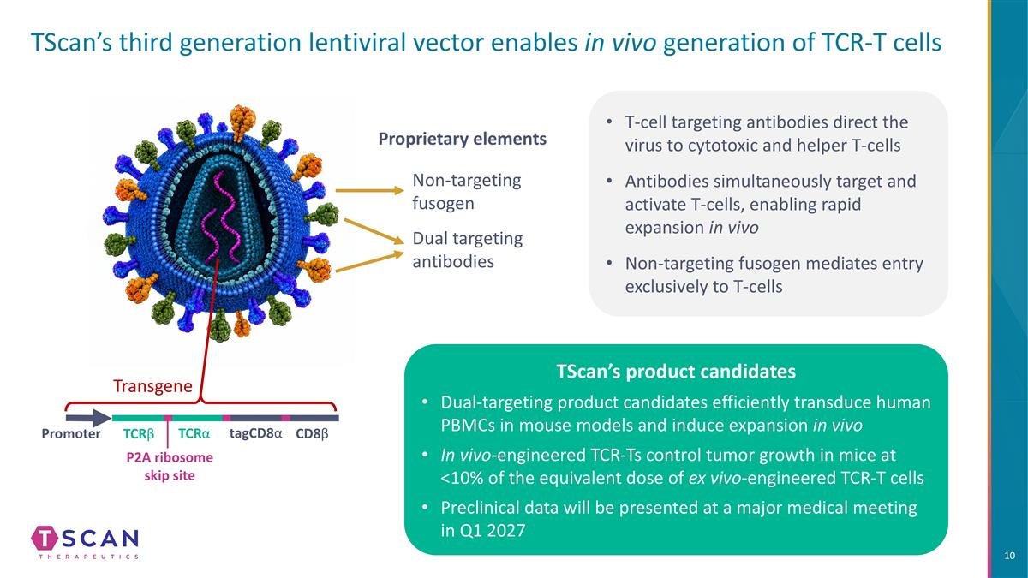
T-cell targeting antibodies direct the virus to cytotoxic and helper T-cells Antibodies simultaneously target and activate T-cells, enabling rapid expansion in vivo Non-targeting fusogen mediates entry exclusively to T-cells TScan’s third generation lentiviral vector enables in vivo generation of TCR-T cells Dual targeting antibodies Non-targeting fusogen Transgene Promoter TCRβ TCRα tagCD8α CD8β P2A ribosome skip site Proprietary elements TScan’s product candidates Dual-targeting product candidates efficiently transduce human PBMCs in mouse models and induce expansion in vivo In vivo-engineered TCR-Ts control tumor growth in mice at <10% of the equivalent dose of ex vivo-engineered TCR-T cells Preclinical data will be presented at a major medical meeting in Q1 2027

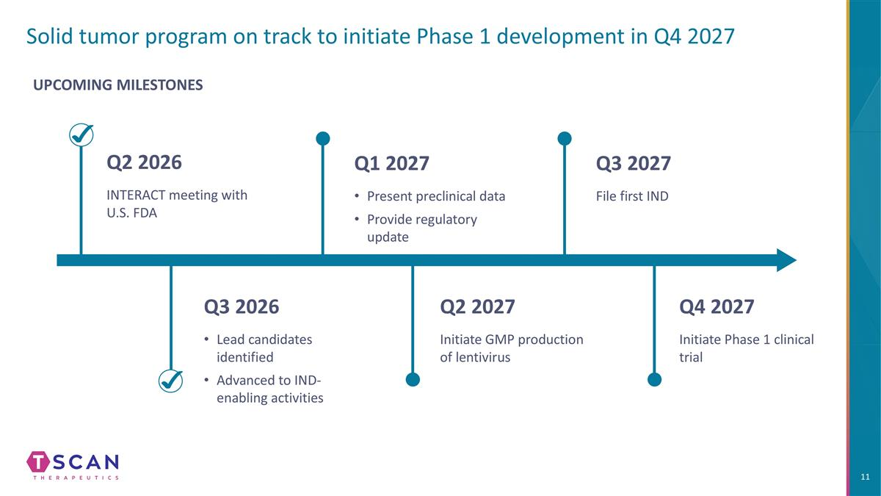
Solid tumor program on track to initiate Phase 1 development in Q4 2027 UPCOMING MILESTONES Q2 2026 INTERACT meeting with U.S. FDA Q1 2027 Present preclinical data Provide regulatory update Q3 2027 File first IND Q3 2026 Lead candidates identified Advanced to IND-enabling activities Q2 2027 Initiate GMP production of lentivirus Q4 2027 Initiate Phase 1 clinical trial

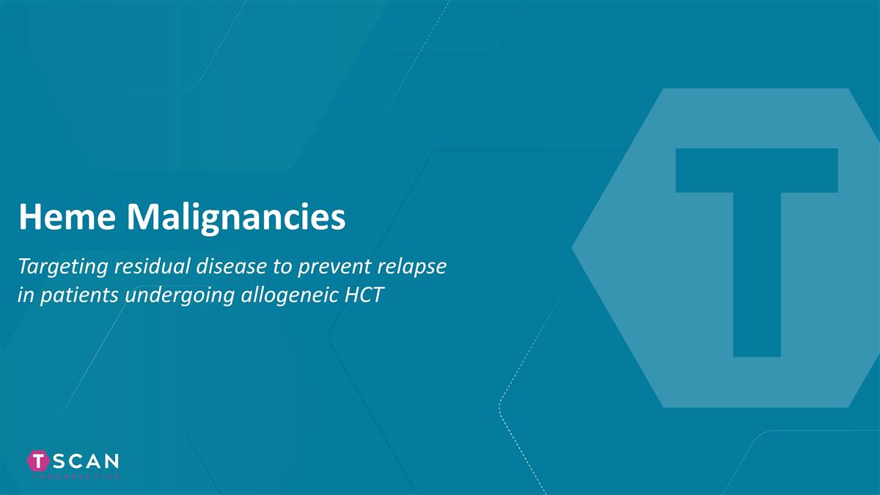
Heme Malignancies Targeting residual disease to prevent relapse in patients undergoing allogeneic HCT

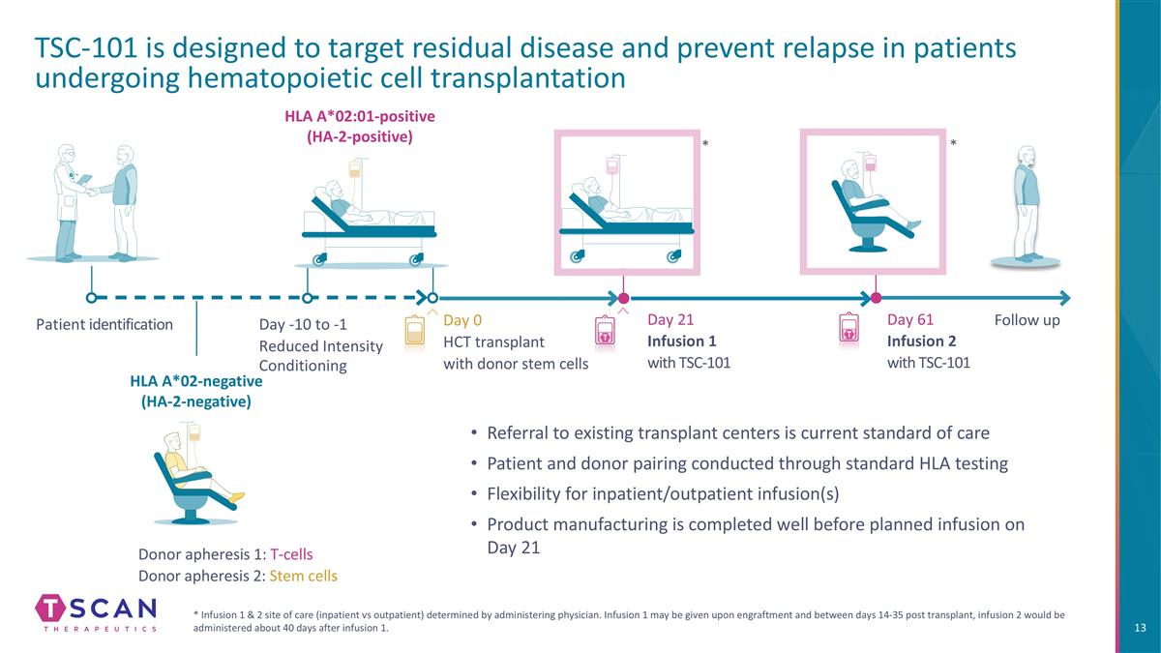
TSC-101 is designed to target residual disease and prevent relapse in patients undergoing hematopoietic cell transplantation * Infusion 1 & 2 site of care (inpatient vs outpatient) determined by administering physician. Infusion 1 may be given upon engraftment and between days 14-35 post transplant, infusion 2 would be administered about 40 days after infusion 1. Patient identification Day 0 HCT transplant with donor stem cells Donor apheresis 1: T-cells Donor apheresis 2: Stem cells Day 21 Infusion 1 with TSC-101 Day 61 Infusion 2 with TSC-101 Follow up Day -10 to -1 Reduced Intensity Conditioning * * HLA A*02:01-positive (HA-2-positive) HLA A*02-negative (HA-2-negative) Referral to existing transplant centers is current standard of care Patient and donor pairing conducted through standard HLA testing Flexibility for inpatient/outpatient infusion(s) Product manufacturing is completed well before planned infusion on Day 21

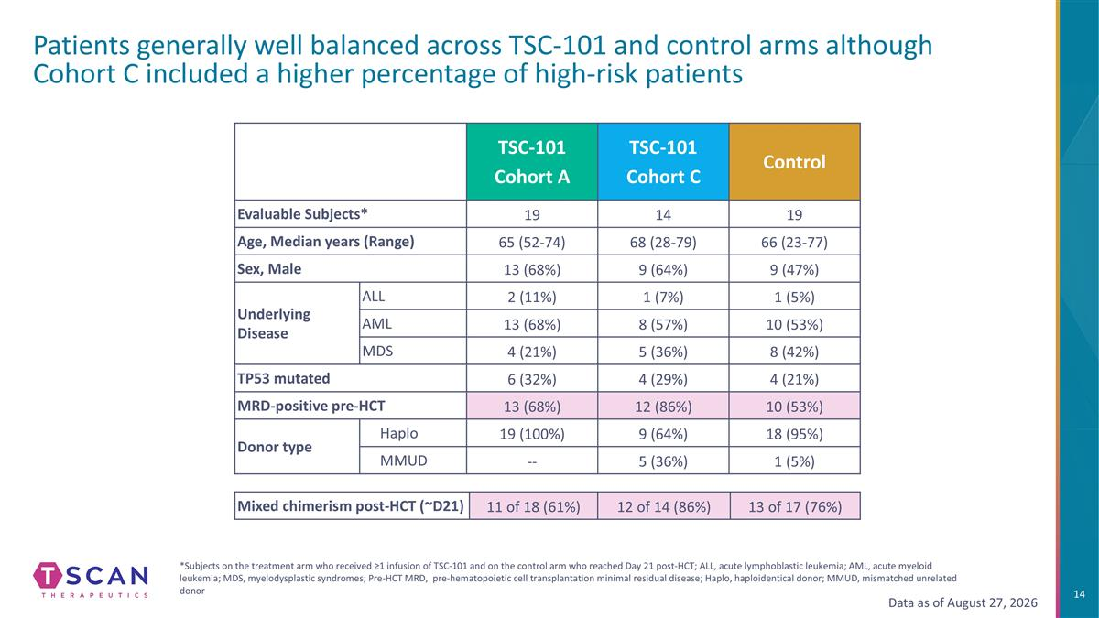
Patients generally well balanced across TSC-101 and control arms although Cohort C included a higher percentage of high-risk patients TSC-101 Cohort A TSC-101 Cohort C Control Evaluable Subjects* 19 14 19 Age, Median years (Range) 65 (52-74) 68 (28-79) 66 (23-77) Sex, Male 13 (68%) 9 (64%) 9 (47%) Underlying Disease ALL 2 (11%) 1 (7%) 1 (5%) AML 13 (68%) 8 (57%) 10 (53%) MDS 4 (21%) 5 (36%) 8 (42%) TP53 mutated 6 (32%) 4 (29%) 4 (21%) MRD-positive pre-HCT 13 (68%) 12 (86%) 10 (53%) Donor type Haplo 19 (100%) 9 (64%) 18 (95%) MMUD -- 5 (36%) 1 (5%) *Subjects on the treatment arm who received ≥1 infusion of TSC-101 and on the control arm who reached Day 21 post-HCT; ALL, acute lymphoblastic leukemia; AML, acute myeloid leukemia; MDS, myelodysplastic syndromes; Pre-HCT MRD, pre-hematopoietic cell transplantation minimal residual disease; Haplo, haploidentical donor; MMUD, mismatched unrelated donor Mixed chimerism post-HCT (~D21) 11 of 18 (61%) 12 of 14 (86%) 13 of 17 (76%) Data as of August 27, 2026

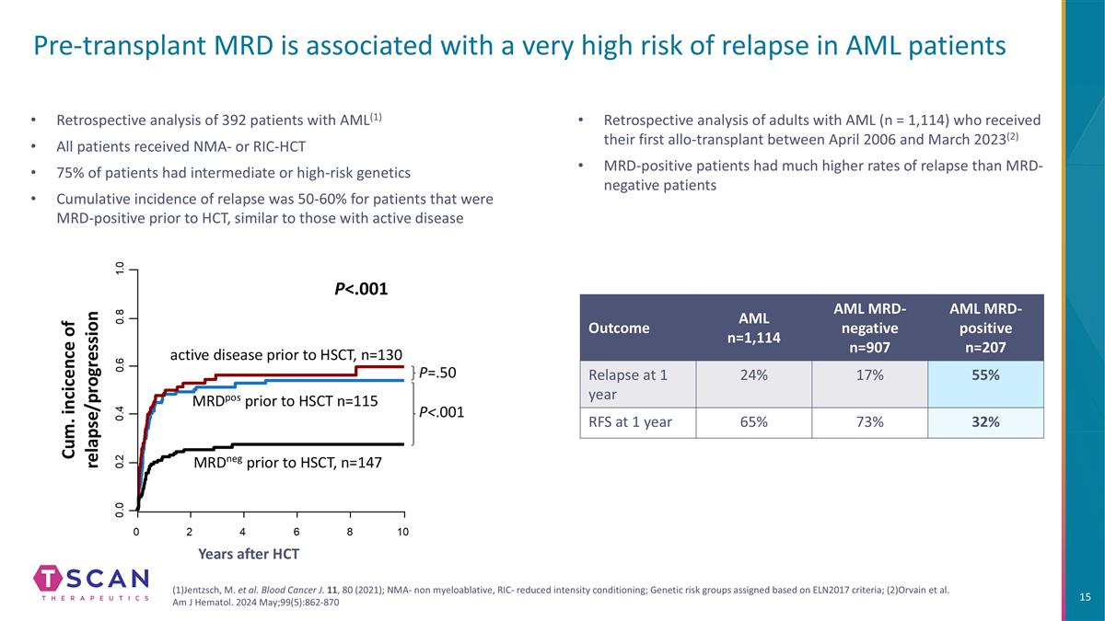
Pre-transplant MRD is associated with a very high risk of relapse in AML patients Retrospective analysis of 392 patients with AML(1) All patients received NMA- or RIC-HCT 75% of patients had intermediate or high-risk genetics Cumulative incidence of relapse was 50-60% for patients that were MRD-positive prior to HCT, similar to those with active disease Years after HCT Retrospective analysis of adults with AML (n = 1,114) who received their first allo-transplant between April 2006 and March 2023(2) MRD-positive patients had much higher rates of relapse than MRD-negative patients (1)Jentzsch, M. et al. Blood Cancer J. 11, 80 (2021); NMA- non myeloablative, RIC- reduced intensity conditioning; Genetic risk groups assigned based on ELN2017 criteria; (2)Orvain et al. Am J Hematol. 2024 May;99(5):862-870 Outcome AML n=1,114 AML MRD-negative n=907 AML MRD-positive n=207 Relapse at 1 year 24% 17% 55% RFS at 1 year 65% 73% 32%

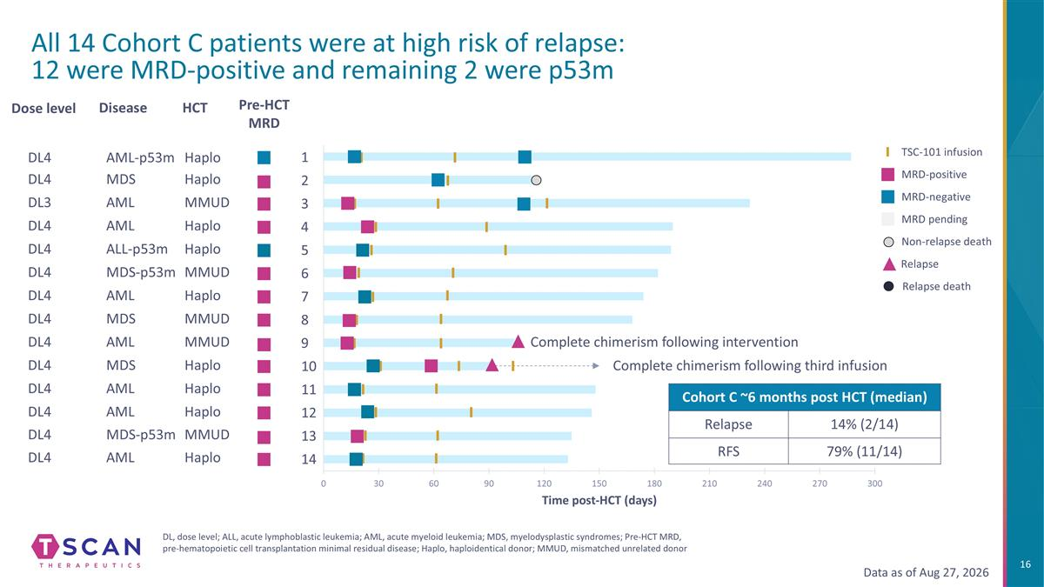
All 14 Cohort C patients were at high risk of relapse: 12 were MRD-positive and remaining 2 were p53m Disease Time post-HCT (days) MRD-positive MRD-negative MRD pending TSC-101 infusion Pre-HCT MRD Dose level HCT DL3AMLMMUD DL4MDSHaplo DL4AMLHaplo DL4ALL-p53mHaplo DL4MDS-p53mMMUD DL4AMLHaplo DL4MDSMMUD DL4AMLMMUD DL4MDSHaplo DL4AMLHaplo DL4AMLHaplo DL4MDS-p53mMMUD DL4AMLHaplo Non-relapse death DL, dose level; ALL, acute lymphoblastic leukemia; AML, acute myeloid leukemia; MDS, myelodysplastic syndromes; Pre-HCT MRD, pre-hematopoietic cell transplantation minimal residual disease; Haplo, haploidentical donor; MMUD, mismatched unrelated donor DL4AML-p53mHaplo 1 2 3 4 5 6 7 8 9 10 11 12 13 14 Relapse Data as of Aug 27, 2026 Complete chimerism following third infusion Relapse death Complete chimerism following intervention Cohort C ~6 months post HCT (median) Relapse 14% (2/14) RFS 79% (11/14)

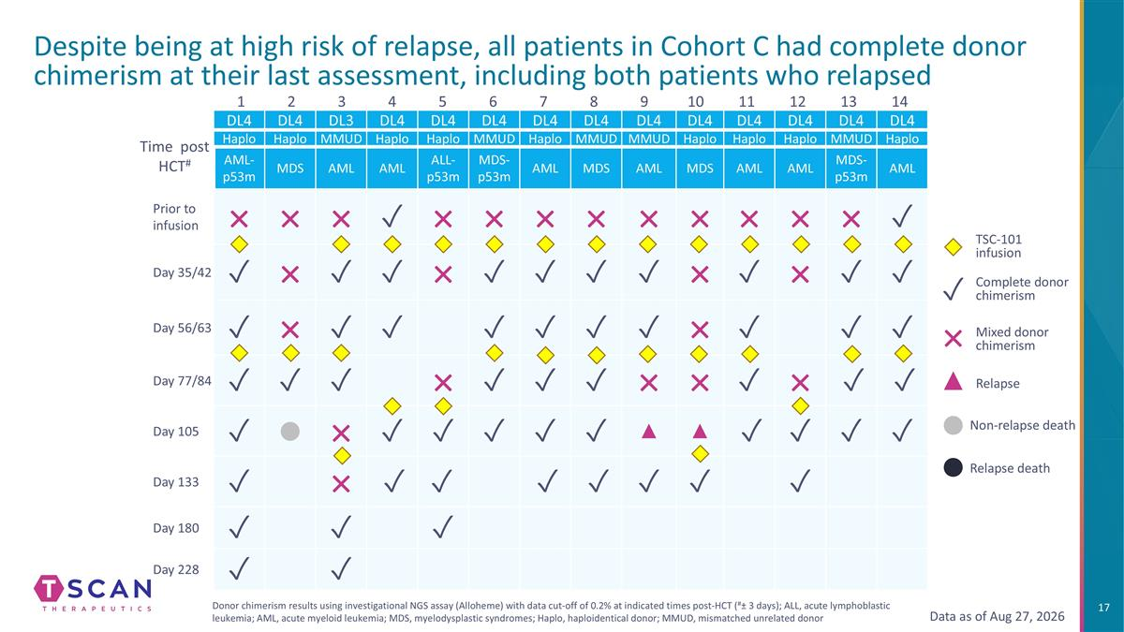
04-022 07-012 13-014 14-003 25-016 13-016 14-004 13-018 13-021 07-013 27-004 16-003 13-017 13-019 1 2 3 4 5 6 7 8 9 10 11 12 13 14 Despite being at high risk of relapse, all patients in Cohort C had complete donor chimerism at their last assessment, including both patients who relapsed DL4 DL4 DL3 DL4 DL4 DL4 DL4 DL4 DL4 DL4 DL4 DL4 DL4 DL4 Haplo Haplo MMUD Haplo Haplo MMUD Haplo MMUD MMUD Haplo Haplo Haplo MMUD Haplo AML-p53m MDS AML AML ALL-p53m MDS-p53m AML MDS AML MDS AML AML MDS-p53m AML Prior to infusion × × × ✓ × × × × × × × × × ✓ Day 35/42 ✓ × ✓ ✓ × ✓ ✓ ✓ ✓ × ✓ × ✓ ✓ Day 56/63 ✓ × ✓ ✓ ✓ ✓ ✓ ✓ × ✓ ✓ ✓ Day 77/84 ✓ ✓ ✓ × ✓ ✓ ✓ × × ✓ × ✓ ✓ Day 105 ✓ ● × ✓ ✓ ✓ ✓ ✓ ▲ ▲ ✓ ✓ ✓ ✓ Day 133 ✓ × ✓ ✓ ✓ ✓ ✓ ✓ ✓ Day 180 ✓ ✓ ✓ Day 228 ✓ ✓ Time post HCT# TSC-101 infusion Complete donor chimerism Mixed donor chimerism × ✓ ● Non-relapse death ● Relapse Relapse death Data as of Aug 27, 2026 Donor chimerism results using investigational NGS assay (Alloheme) with data cut-off of 0.2% at indicated times post-HCT (#± 3 days); ALL, acute lymphoblastic leukemia; AML, acute myeloid leukemia; MDS, myelodysplastic syndromes; Haplo, haploidentical donor; MMUD, mismatched unrelated donor

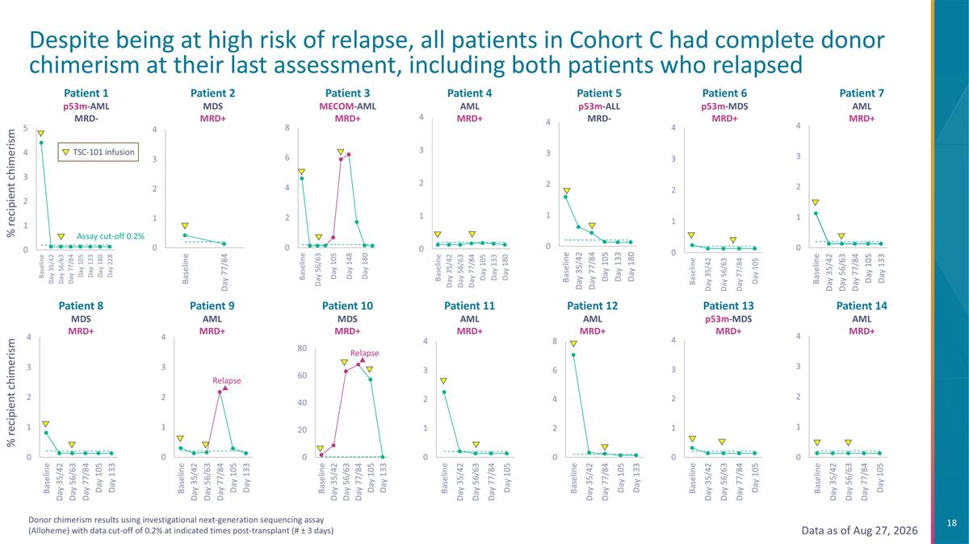
Despite being at high risk of relapse, all patients in Cohort C had complete donor chimerism at their last assessment, including both patients who relapsed % recipient chimerism % recipient chimerism Donor chimerism results using investigational next-generation sequencing assay (Alloheme) with data cut-off of 0.2% at indicated times post-transplant (# ± 3 days) Assay cut-off 0.2% Patient 1 p53m-AML MRD- Patient 2 MDS MRD+ Patient 3 MECOM-AML MRD+ Patient 4 AML MRD+ Patient 5 p53m-ALL MRD- Patient 6 p53m-MDS MRD+ Patient 7 AML MRD+ Patient 8 MDS MRD+ Patient 9 AML MRD+ Patient 10 MDS MRD+ Patient 11 AML MRD+ Patient 12 AML MRD+ Patient 13 p53m-MDS MRD+ Patient 14 AML MRD+ TSC-101 infusion Data as of Aug 27, 2026 Relapse Relapse

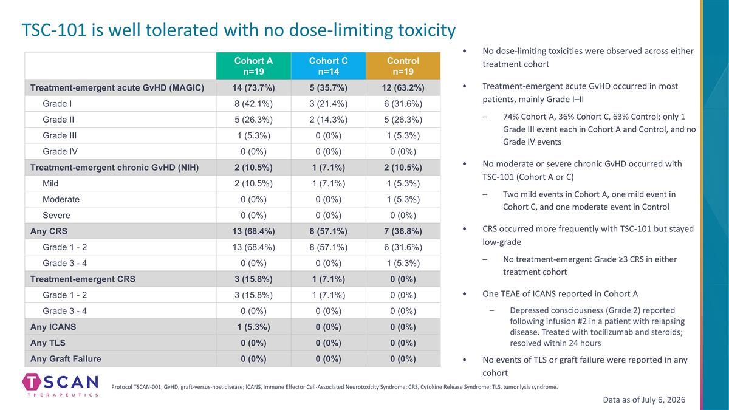
No dose-limiting toxicities were observed across either treatment cohort Treatment-emergent acute GvHD occurred in most patients, mainly Grade I–II 74% Cohort A, 36% Cohort C, 63% Control; only 1 Grade III event each in Cohort A and Control, and no Grade IV events No moderate or severe chronic GvHD occurred with TSC-101 (Cohort A or C) Two mild events in Cohort A, one mild event in Cohort C, and one moderate event in Control CRS occurred more frequently with TSC-101 but stayed low-grade No treatment-emergent Grade ≥3 CRS in either treatment cohort One TEAE of ICANS reported in Cohort A Depressed consciousness (Grade 2) reported following infusion #2 in a patient with relapsing disease. Treated with tocilizumab and steroids; resolved within 24 hours No events of TLS or graft failure were reported in any cohort Protocol TSCAN-001; GvHD, graft-versus-host disease; ICANS, Immune Effector Cell-Associated Neurotoxicity Syndrome; CRS, Cytokine Release Syndrome; TLS, tumor lysis syndrome. TSC-101 is well tolerated with no dose-limiting toxicity Cohort A n=19 Cohort C n=14 Control n=19 Treatment-emergent acute GvHD (MAGIC) 14 (73.7%) 5 (35.7%) 12 (63.2%) Grade I 8 (42.1%) 3 (21.4%) 6 (31.6%) Grade II 5 (26.3%) 2 (14.3%) 5 (26.3%) Grade III 1 (5.3%) 0 (0%) 1 (5.3%) Grade IV 0 (0%) 0 (0%) 0 (0%) Treatment-emergent chronic GvHD (NIH) 2 (10.5%) 1 (7.1%) 2 (10.5%) Mild 2 (10.5%) 1 (7.1%) 1 (5.3%) Moderate 0 (0%) 0 (0%) 1 (5.3%) Severe 0 (0%) 0 (0%) 0 (0%) Any CRS 13 (68.4%) 8 (57.1%) 7 (36.8%) Grade 1 - 2 13 (68.4%) 8 (57.1%) 6 (31.6%) Grade 3 - 4 0 (0%) 0 (0%) 1 (5.3%) Treatment-emergent CRS 3 (15.8%) 1 (7.1%) 0 (0%) Grade 1 - 2 3 (15.8%) 1 (7.1%) 0 (0%) Grade 3 - 4 0 (0%) 0 (0%) 0 (0%) Any ICANS 1 (5.3%) 0 (0%) 0 (0%) Any TLS 0 (0%) 0 (0%) 0 (0%) Any Graft Failure 0 (0%) 0 (0%) 0 (0%) Data as of July 6, 2026

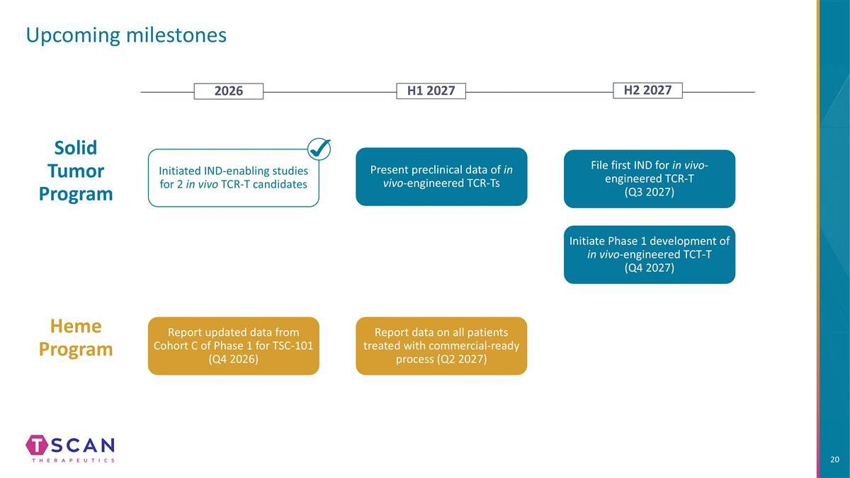
Upcoming milestones Solid Tumor Program 2026 H1 2027 Initiated IND-enabling studies for 2 in vivo TCR-T candidates H2 2027 File first IND for in vivo-engineered TCR-T (Q3 2027) Heme Program Report updated data from Cohort C of Phase 1 for TSC-101 (Q4 2026) Report data on all patients treated with commercial-ready process (Q2 2027) Present preclinical data of in vivo-engineered TCR-Ts Initiate Phase 1 development of in vivo-engineered TCT-T (Q4 2027)


THANK YOU

